Segmentation & Profiling Project
DSE5004
June Lemieux

Executive Summary

Introduction
Disciplined customer segmentation provides curated data to inspire and support marketing efforts. Employing best accepted practices allows the process to be validated and reused. When faced with the challenge of developing new, successful, and cost-effective marketing tactics, having a well-segmented data set supports the effort by supplying relevant profiles. As a result, targeted marketing methods can be effectively and efficiently launched. This paper will document the process of segment development from objective identification to the comparison of available resources and techniques, then to the selection of a preferred technique, through the description and refinement of customer profiles, and end with the recommendations for next steps.

Objective
Develop customer segments that support effective, economically sound, customer retention and marketing efforts.

Methodology
The basis of the segmentation process is customer data. In this effort, the rich data set consisted of a single file with 5,000 customer records. The data set included a few minor data anomalies that were easily mitigated or ignored, as deemed appropriate. The initial data review indicated balanced values in most of the variables. Said another way, there were very few significant outliers or unexpected values.
Of the many segmentation techniques, the two chosen for the initial comparison were the k-means clustering unsupervised method and the rules-based method in which the number of segments is provided. These two were chosen because of their ease of implementation and reuse. These characteristics, especially reuse, were necessary to help sift through the wide variety of variable combinations before finding a suitable combination that supported the segmentation objective.

Key Findings

Delineation
Although the outputs of the two techniques were similar, the k-means technique was selected because the segments were more clearly delineated than the rules-based technique. Using this technique, five segments were identified by k-means technique, and four identified by the rules-based technique.

Opportunities
Both techniques exposed products that would benefit from precise marketing tactics. Combining the clear profiling of the k-means technique with these underperforming products should provide adequate knowledge for successful, meaningful retention and revenue building.

Result
As a result of the segmentation exercise, two segments were identified as being targets for enhanced communication about specific beneficial products. There is an opportunity in one of the segments to increase marketing and sales of the internet product, while there is an opportunity in the other segment to increase marketing and sales of the calling products. Assuming an average price of $11/product/month and 50% of these customers purchasing just one of these underperforming products, the overall monthly sales increase would be nearly $18,000, equaling a 5.5% increase.

Conclusion
The segmentation process yielded encouraging results by highlighting some sales opportunities and sufficient customer information to be able to act on those opportunities. Additional work is needed to determine what type of marketing techniques should be used to capitalize on these opportunities. Furthermore, the remaining segments not highlighted in this document should also be analyzed for product boosting and customer retention opportunities.

Technical Discussion

Resource
The segmentation exercise began with a single file of data for 5,000 customers. The types of data present included geographic, demographic, employment, financial, pet information, and data specific to the telecommunications preferences, behaviors, and traits for each customer. The raw data required some cleansing and wrangling, but overall, the data was generally complete and useful for the purposes of this segmentation exercise.

Technique Comparison
To properly ensure that this project resulted in quality segments, two segmentation techniques were evaluated. The first was the rule-based segmentation technique, selected because it would be useful for continuous and/or categorical variables, and because of the ease of switching out variables and selecting count of segments. The second was the k-means segmentation technique, which works on numeric data (or categorical data that has been mapped to numbers in a meaningful way). K-means was also chosen because of the ease of switching out variables and for controlling the number of segments.
After running many variable combinations through both techniques, the following variable set was established:
- Total Telecom Spend Last Month: This amount is the total amount each customer paid to the telecommunications company last month. The amounts had no pattern, so it was assumed that each customer was billed on the products and services they had selected.
- Product Count: This amount is the count of individual products and services each customer purchased. The highest possible product count is 13. The list of individual products can be found in Appendix A.
- Phone Company Tenure: The number of months the customer has been with this phone company. This metric was included because of the theory that the longer a telecommunications customer uses a telecom company, the longer that customer will continue to stay with the company (Burnett, 2014)
Additionally, the number of segments was determined to be four. The K-means technique generated five segments, but one segment was very small and was easily blended with a larger, very similar segment.
A comparison of scatterplots from each set of segments was interesting.
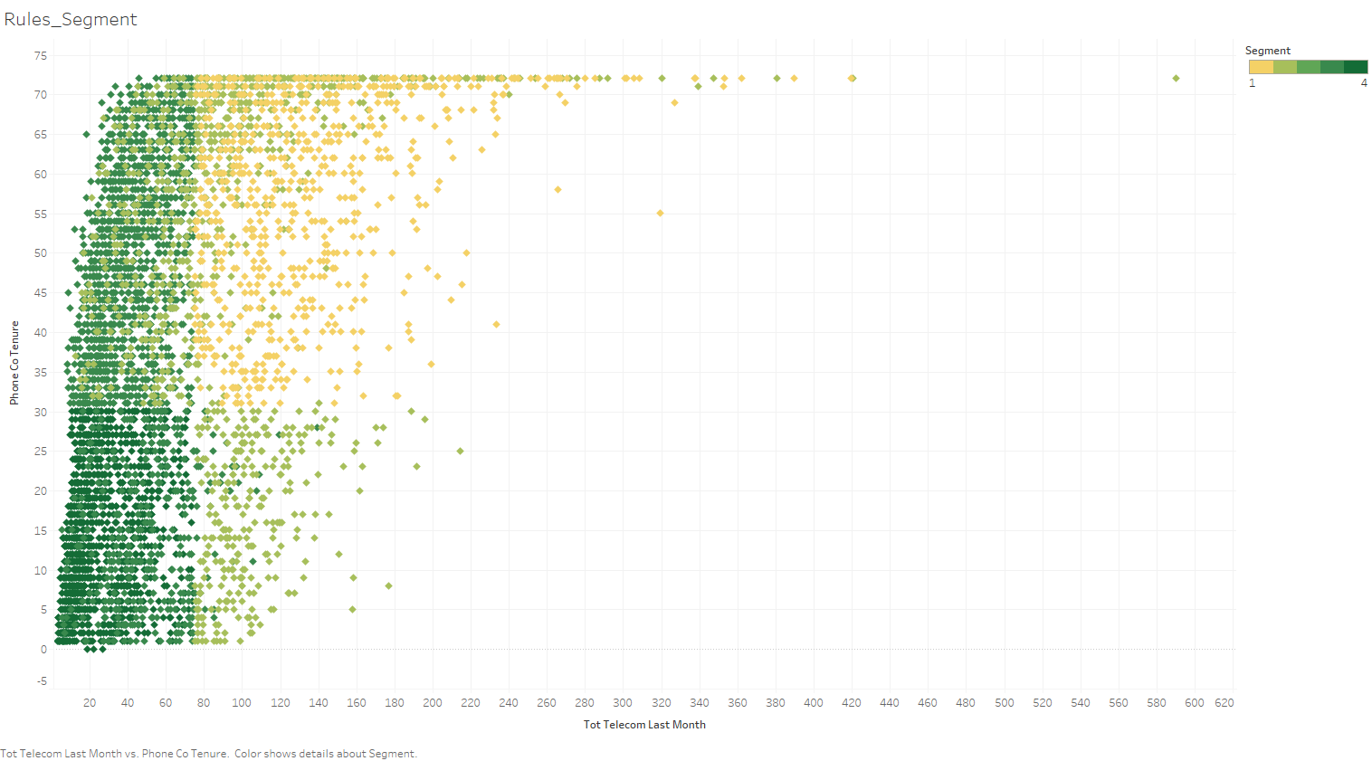
Figure 1: Scatterplot from rules-based segmentation.

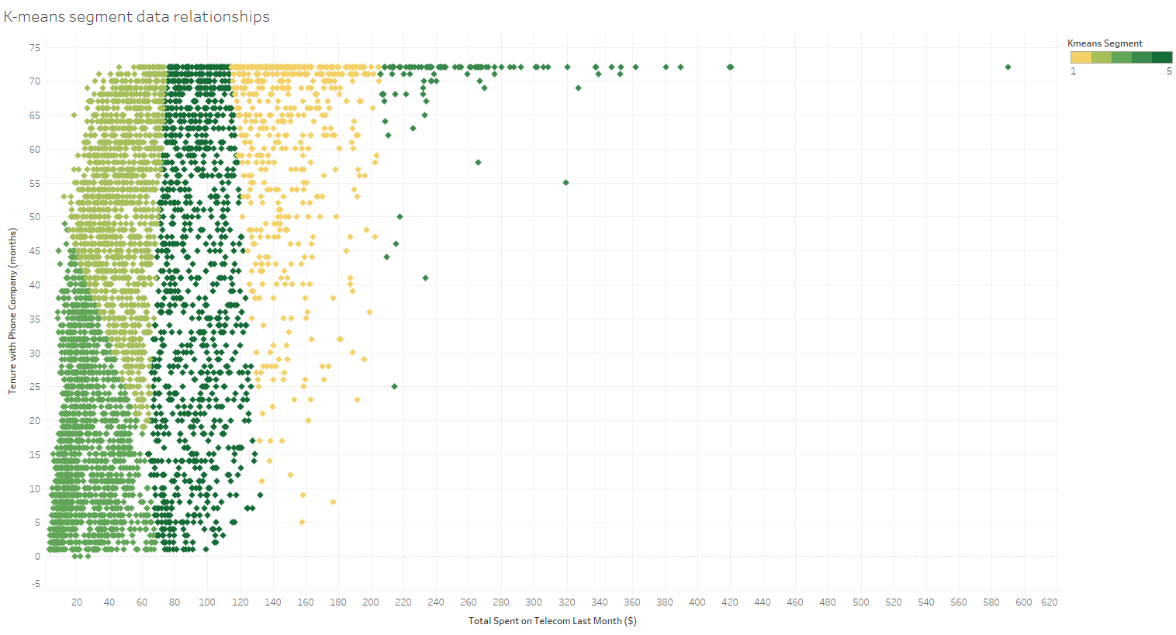
Figure 2: Scatterplot from k-means segmentation.

Selection of K-means
After reviewing these scatterplots and noting the clean separation of segments in Figure 2, the k-means segmentation technique was selected as the technique to use for the remainder of the exercise.
It is important to note that although the segments were neatly differentiated in the k-means process, the initial result was five segments with the following information:
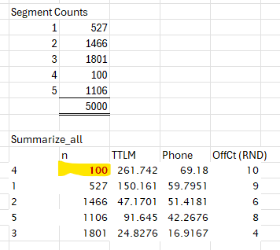
Figure 3: k-means initial segment information
Segment 4 was so small that it almost appeared to be an outlier, but it was treated as an individual segment.

Analyzing Segments, part 1
Additional interesting information from Figure 3 was the Product Count (identified by “OffCt (RND)”). The highest possible product count is 13, but only one segment comes close to that number.
The raw segment breakdown looked like this pie chart: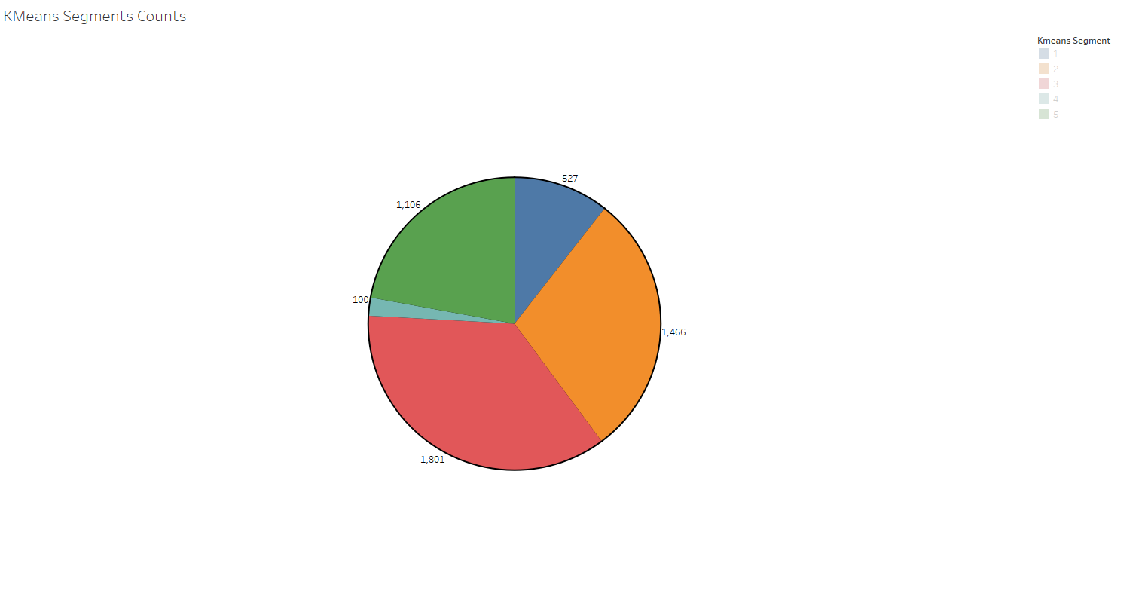
Figure 4: k-means segment breakdown and customer count.

Calculating Opportunity
Noticing that Product Count was lower than provided an idea that maybe it is possible that there are underperforming products in the product line. To say it another way: would the company make more money if customers were convinced to buy just one more product? Some basic details included:
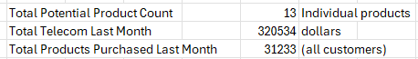
Figure 5: Totals
These numbers were used to identify the average telecom cost per customer last month as $64.11 and the average number of products purchased was 6.25, rounded down to 6.
Based on those averages, a theory was developed that identified $11 as the approximate price per product per month:
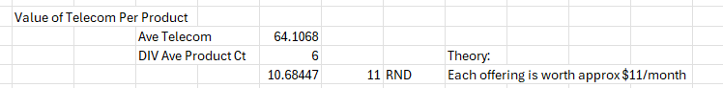Figure 6: Price per Product Offered
Revisiting the segment breakdown again and sorting by the Product Count presents Segments 2 and 3 as potential target segments:
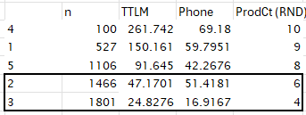
Figure 7: Summarize_All Information
If $11/product/month is a valid estimate, then increasing product purchases by 1 by 50% of the customers in Segments 2 and 3 would result in a revenue improvement as follows:
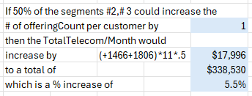
Figure 8: Recommendation
A 5.5% increase in revenue is always welcomed.

Analyzing Segments, part 2
A deeper dive into the segments yielded additional interesting insights about each segment:
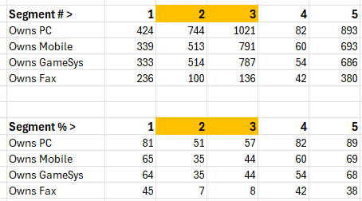
Figure 9: Count and percentage of ownership in each segment.
The low ownership of PCs, mobile devices, and gaming systems in Segments 2 and 3 was unexpected but could be supported by the theory of a digital divide in the country. Still, revenue opportunities could still exist.
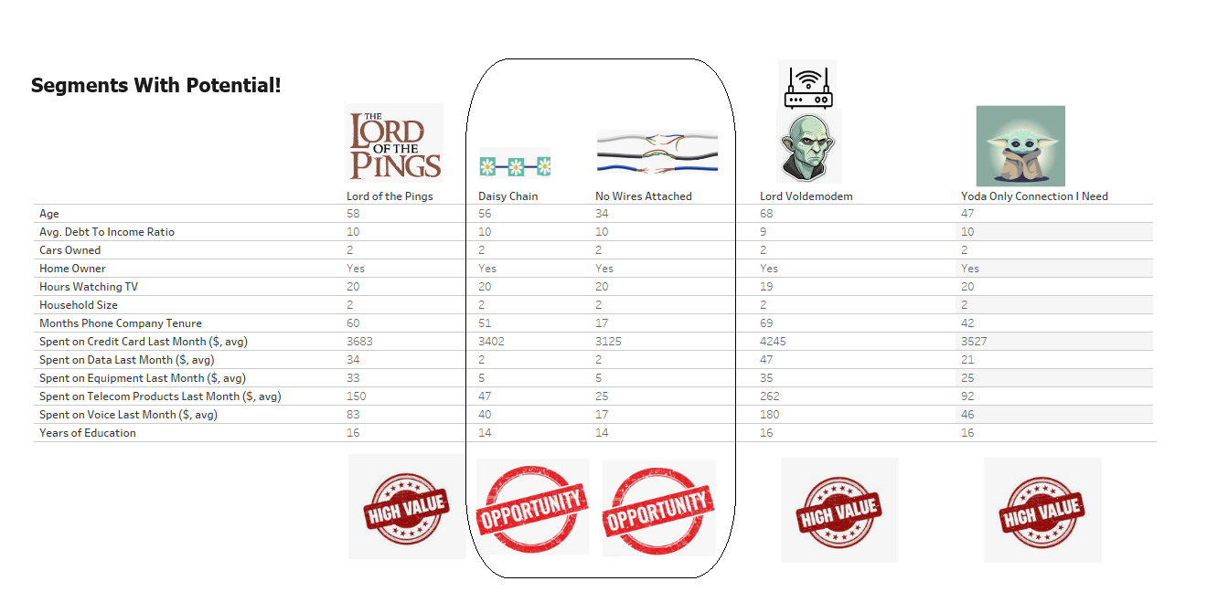Figure 10: Identifying segments with potential

Summary of Segments
Below is the segment breakdown of customers:
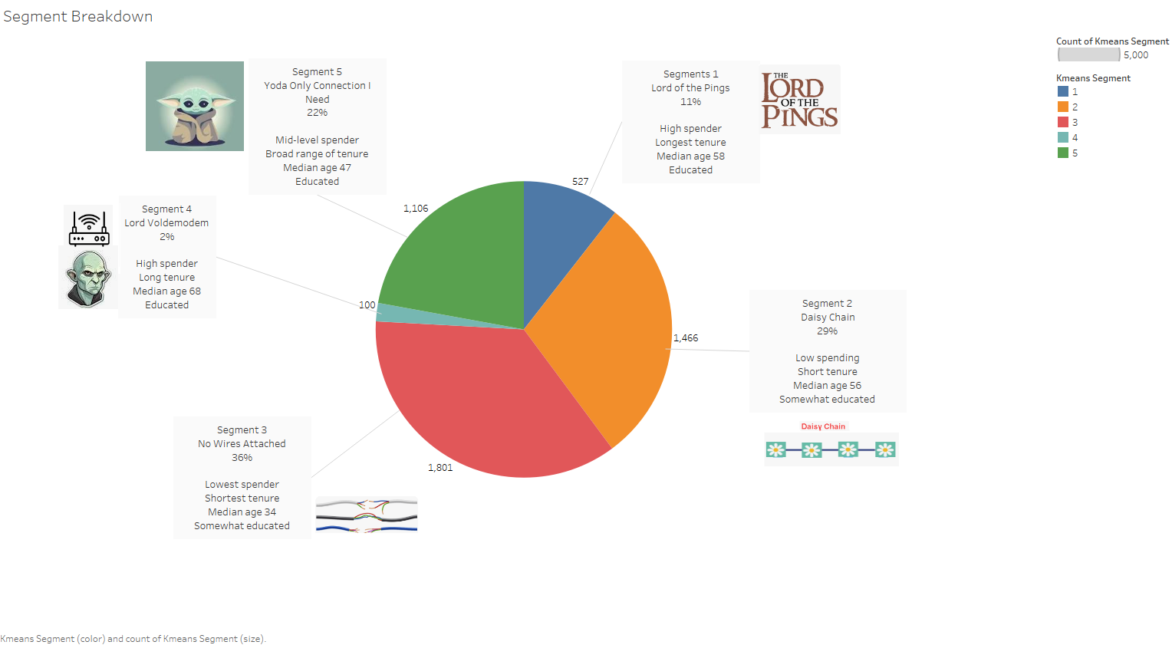
Figure 11: Summary of Segments
Note that the names of the segments are attributed to (Kuehn, 2024)

Customer Segment 1: Daisy Chain
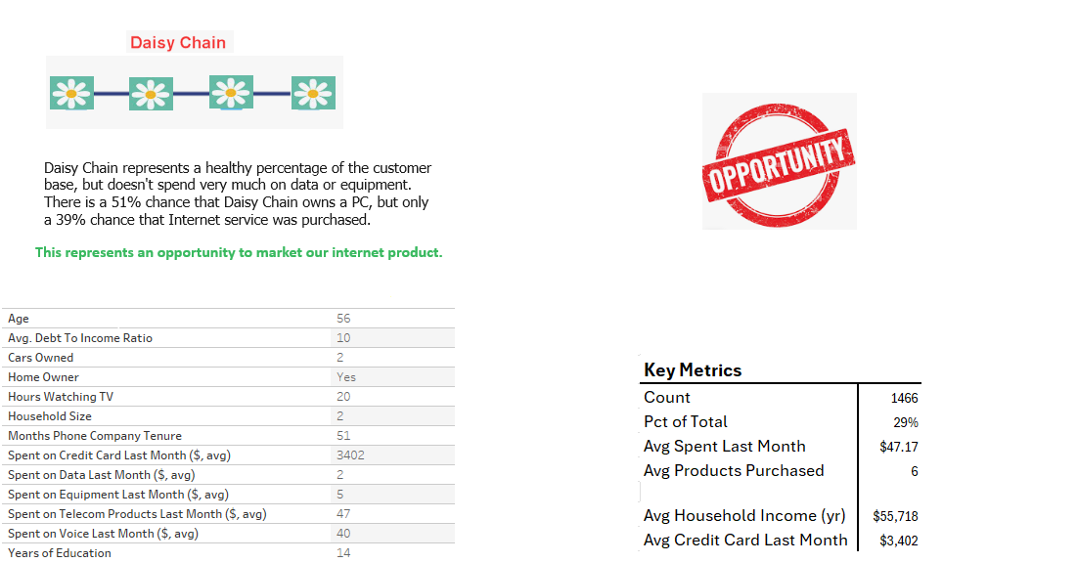
Figure 12: Daisy Chain Segment

Customer Segment 2: No Wires Attached

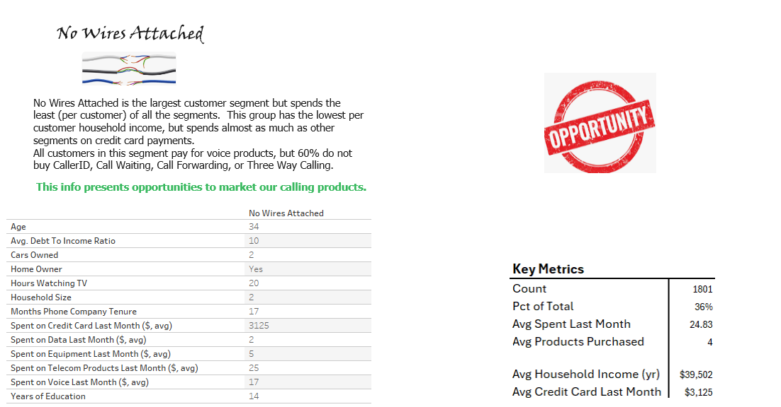
Figure 13: No Wires Attached Segment

Recommendations
Daisy Chain could present an opportunity to sell additional internet service. Fifty-one percent of the customers in the segment own a PC. However, only 39% of the segment has purchased any internet service. By marketing the internet service to this customer profile, the company may be able to encourage some customers to purchase the additional service.
Likewise, No Wires Attached appears to be under-utilizing some products and services. In this segment, all customers pay for voice products. Unfortunately, a whopping 60% of customers do not buy any of the standard calling services, for example, CallerID, Call Waiting, Call Forwarding, or Three Way Calling. It is possible that this group might not be taking full advantage of the services available to them. Proper marketing might be able to change that perspective.

Appendix A – List of individual products included in Product Count
- Caller ID
- Call Forwarding
- Calling Card
- Call Waiting
- Equipment Rental
- Internet services
- Multiline product
- NewsSubscriber service
- Pager
- Three-way calling service
- Voice mail
- Wireless data
- Voice service

References
Burnett, T. (2014). The Impact of Service Bundling on Consumer Switching Behaviour: Evidence from UK Communication Markets. The Centre for Market and Public Organisation. Bristol, England: The University Of Bristol. Retrieved from http://www.bristol.ac.uk/media-library/sites/cmpo/migrated/documents/wp321.pdf
Kuehn, K. (2024, 02 01). 125 Funny Wi-Fi Names for a Hilarious Internet Connection. Retrieved from Reader's Digest: https://www.rd.com/article/funny-wi-fi-network-names/

